
MARLY 1.0
Model-Assisted Rescue for Lost-person recoverY
Executive Summary — Development Progress Report (Updated)
Date: May 20, 2026 | Version: 1.0 | Lines of Code: 1,773

Project Overview
MARLY 1.0 is a web-based Search and Rescue (SAR) planning tool built in Python using Flask. It automates the generation of search zones, probability rings, trail corridors, and operational markers based on lost person behavioral profiles from the Robert Koester / ISRID dataset. MARLY produces KML files that import directly into CalTopo with styled icons, color-coded rings, and search sectors ready for field deployment. The tool includes both a full search plan workflow and a separate hasty search module for rapid first-response planning.

Completed Development

Phase 1 — Data Input Form ✓
- Subject type classification (Dementia, Lost Hiker, Lost Child, Lost Hunter, Lost Vehicle, Mental Health Crisis)
- Last Known Position (latitude/longitude), time last seen, age, terrain type
- Notes field with automatic direction-of-travel parsing
- Data persistence via JSON file storage

Phase 2 — Search Zone Calculation & Export ✓
- 4 probability rings (25%, 50%, 75%, 95%) with customizable distances
- 8 compass-bearing search sectors with dual-priority system
- Directional weighting: 1.5x for dementia exit door, 1.3x for known travel direction
- KML export with CalTopo-native icon styling and color-coded rings
- Single combined KML file output (rings + sectors + markers)
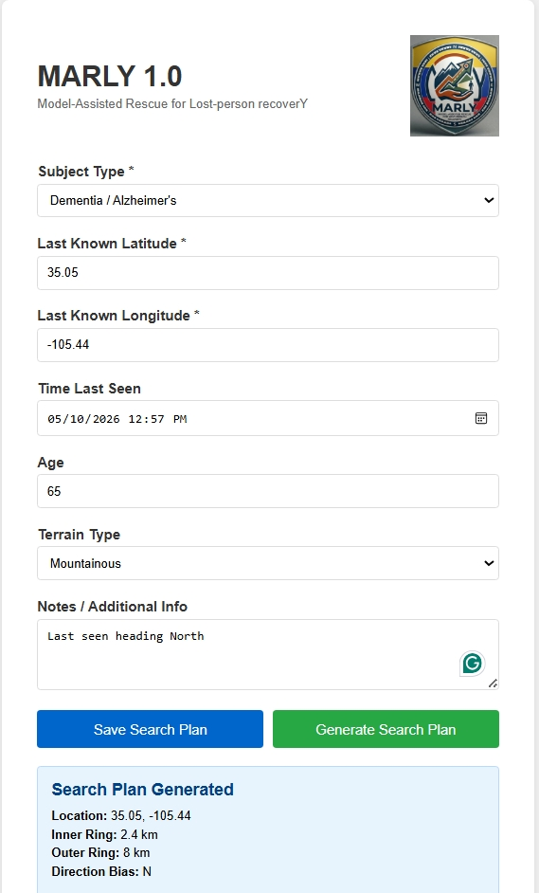
Figure 1: MARLY input form with subject info and search plan generation.

Phase 3 — Search Parameters & Adaptive Sizing ✓
- 3-step workflow: Subject Info → Search Parameters → Operational Markers
- Adaptive sector sizing with automatic subdivision when sectors exceed max area
- Sequential sector numbering: inner ring (Sector-01, 02...), outer ring (Sector-01A, 02A...)
- Grid squares as default sector shape (toggleable to pie sectors)
- Standard units default (miles, feet, acres) with metric toggle
- Team information: number of teams, capability (ground/mounted/K9/aerial/mixed), hours since last seen

Phase 4 — Terrain Awareness & Operational Features ✓
- Terrain-aware weighting via OpenStreetMap (trails weighted 2x, up to 1.5x sector boost)
- Trail/road data file upload (KML/GPX) as alternative to OpenStreetMap
- 8 operational marker types with CalTopo-native icons: ICP, IPP, Staging, Road Block, Hazard, Wx-Weather, Medical, Terrain
- Auto-placement of markers at 9 o'clock outside 75% ring when no coordinates provided
- Weighted sectors display: normal weight = transparent, boosted weight = red shading
- Hasty Search Module (separate page):
- Trail corridor generation with configurable offset (default 100 ft / 30m per side)
- Connected segment merging (reduces fragmented road/trail data into continuous corridors)
- Dead-end filtering (segments under 50m removed)
- Gap sectors (30-acre grid squares) fill areas between trail corridors
- Operational markers available on hasty page with same CalTopo icon support
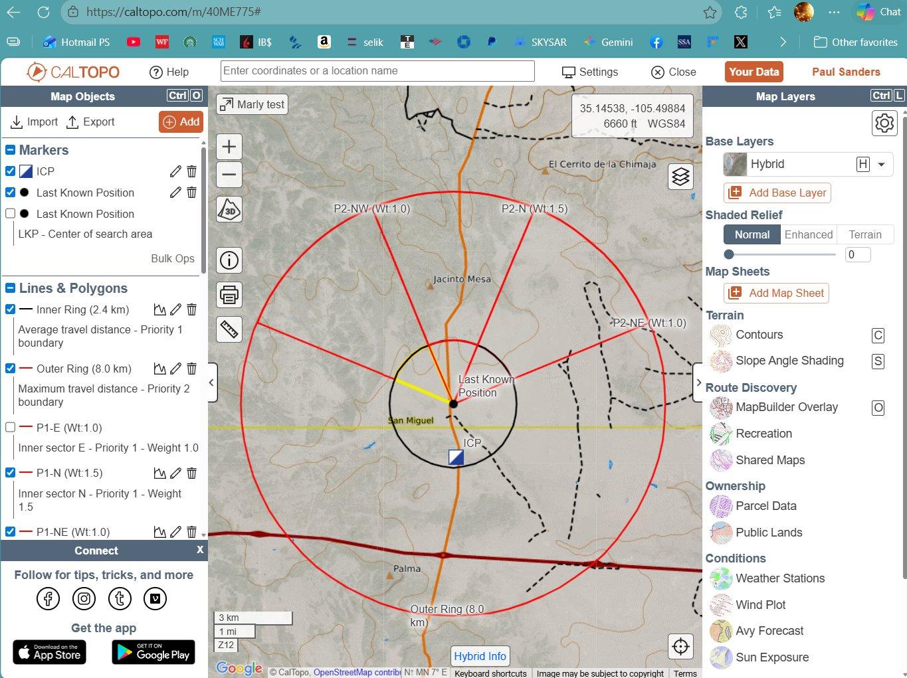
Figure 2: MARLY-generated search plan displayed in CalTopo with rings, sectors, and operational markers.

Phase 5 — Terrain-Shaped Sectors (In Progress)
Phase 5 introduces elevation-aware sector design using USGS 3DEP data. Rather than rigid grid squares, sectors will conform to natural terrain features (ridgelines, drainages, contour lines) for more practical field deployment.

Step 1 — Elevation Data & Feature Detection ✓
- USGS 3DEP elevation data querying (80m grid, 15 parallel threads)
- Ridgeline detection via Laplacian analysis of elevation grid
- Drainage detection (concave terrain features)
- Polyline smoothing for natural-looking terrain feature lines
- KML export with ridgeline and drainage overlays (separate folders in CalTopo)

Step 2 — Terrain Feature Sector Boundaries (Pending)
- Use detected ridgelines and drainages as sector boundaries instead of straight grid lines
- Snap sector edges to nearest terrain feature (ridge spine, creek, trail)
- Maintain 30-50 acre sector size constraint with irregular polygon shapes

Step 3 — Contour-Based Sector Design (Pending)
- "Ribbon" or "Finger" sectors oriented along ridge spines and drainage fall lines
- Elevation band sectors (e.g., 8,800 ft to 9,100 ft contour interval)
- Automatic acreage calculation for irregular terrain-based polygons

Future Development Roadmap

Category-Specific Sector Templates (Planned)
- Unique templates per lost person category (e.g., 60-degree cone for dementia exit door direction)
- Partial ring coverage (only inner rings get sectors for most categories)
- Hasty search template with focused high-probability sectors only

Custom Behavioral Profiles (Planned)
- Upload spreadsheet with custom probability distances to replace or supplement Koester defaults

CalTopo Direct Integration (On Hold)
- Use caltopo_python library to push sectors directly to CalTopo maps
- Eliminate download/import step entirely

UTM/USNG Grid Alignment (On Hold)
- Snap grid sectors to standard UTM/USNG grid lines
- Sector boundaries match topo maps and GPS devices

Built-in Subject Behavioral Profiles
Subject Type | 25% | 50% | 75% | 95% | Units
Dementia | 0.6 | 1.2 | 2.4 | 8.0 | km
Lost Child | 0.4 | 0.8 | 1.6 | 4.5 | km
Lost Hiker | 1.5 | 3.0 | 5.0 | 25.0 | km
Lost Hunter | 1.0 | 2.5 | 4.0 | 15.0 | km
Lost Vehicle | 3.0 | 6.0 | 10.0 | 50.0 | km
Mental Health | 0.8 | 1.5 | 3.0 | 8.0 | km

Technical Details
- Language: Python 3.14
- Framework: Flask (web application)
- Export Format: KML (Google Earth / CalTopo compatible with styled icons)
- Elevation Data: USGS 3DEP via Elevation Point Query Service
- Trail Data: OpenStreetMap Overpass API + KML/GPX file upload
- Behavioral Data: Koester / ISRID lost person behavioral profiles
- Libraries: Flask, lxml, requests, numpy, scipy
- Codebase: 1,773 lines across 3 files (app.py, form.html, hasty.html)
- Hosting: Runs locally on Windows laptop via localhost

MARLY 1.0 is operational and producing field-ready search plans that import directly into CalTopo with styled icons, probability rings, search sectors, trail corridors, and operational markers. The hasty search module enables rapid first-response planning with trail-based corridors and gap sectors. Phase 5 elevation integration is in progress, with terrain feature detection active and contour-based sector shaping as the next development priority. The tool is designed to compress SAR planning time from hours to minutes, providing incident commanders with a data-driven starting framework that planning teams can refine at the ICP.

